

Professors :   
Simona Campisi

Gennaro Trtarisco

Made by:

Mujibullah Rabin





Table of Contents

1.Introduction

2.code explanation

3. CONCLUSION

4.refrences

Emotional State Analysis in Consumer Behavior

INTRODUCTION

This project delves into the dataset "Study 4," focusing on the impact of anxiety on consumer product evaluations among 83 healthy subjects. Through data mining and analytics, we aim to predict emotional states based on psychophysiological responses. The script employs feature selection, PCA, and classification, showcasing a systematic approach from data loading to model evaluation. This analysis aims to be a predictive tool, offering insights into the relationship between anxiety and consumer choices. The constructed model holds implications for understanding and predicting emotional responses in consumer behavior.

Top of Form

CODE EXPLANATION

1. Import necessary libraries

This segment involves importing essential libraries for data analysis and machine learning. These include pandas for data manipulation, matplotlib and seaborn for data visualization, and scikit-learn for machine learning tasks such as model building and evaluation.

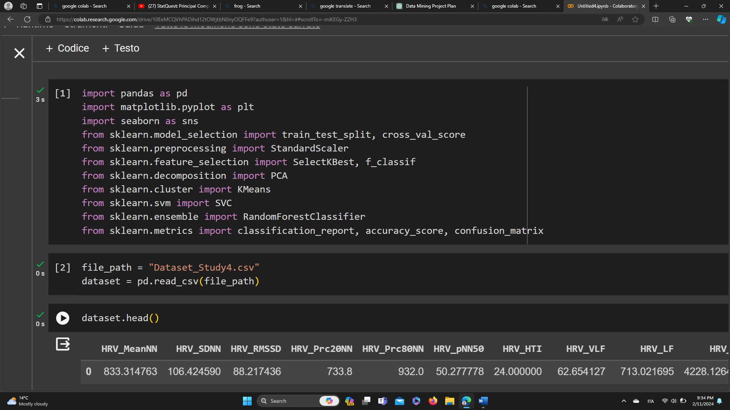

1. Load the dataset

Here, the code reads the dataset from a CSV file into a Pandas DataFrame.

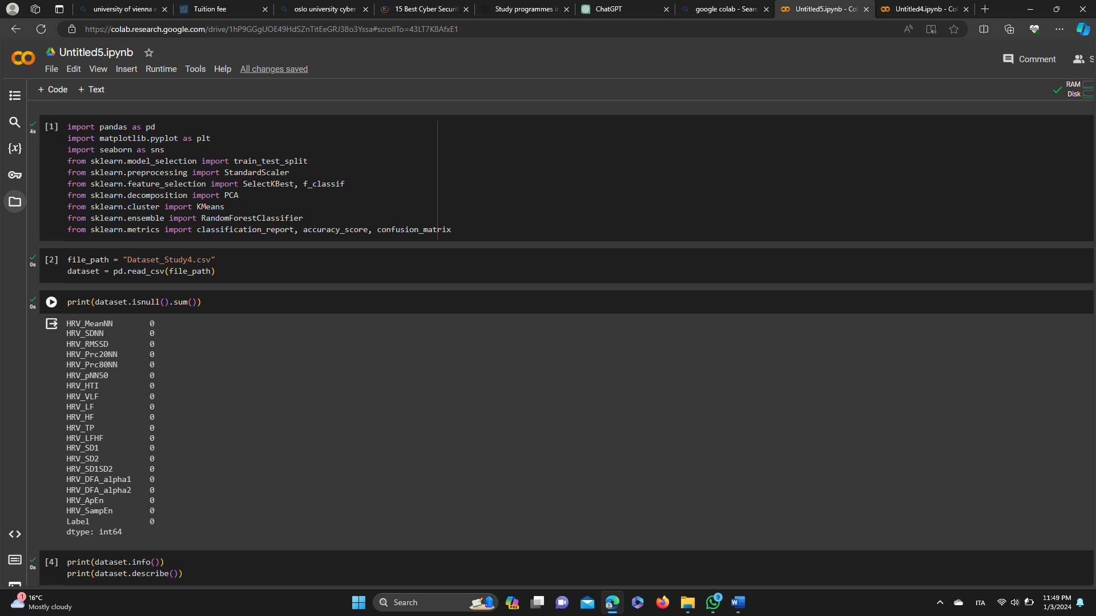

1. Display first few rows of the dataset

The dataset.head() function is used to display the first few rows of the loaded dataset. It's a quick way to get an overview of the structure and content of the data.

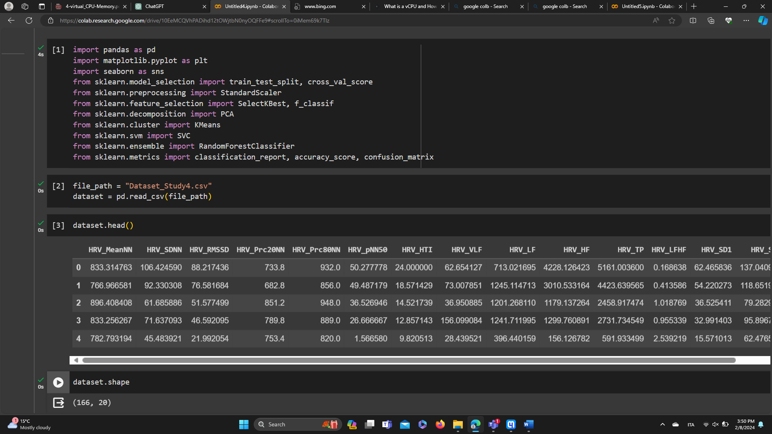

1. Get the shape of the dataset

When you run dataset.shape, it will return a tuple where the first element is the number of rows, and the second element is the number of columns.

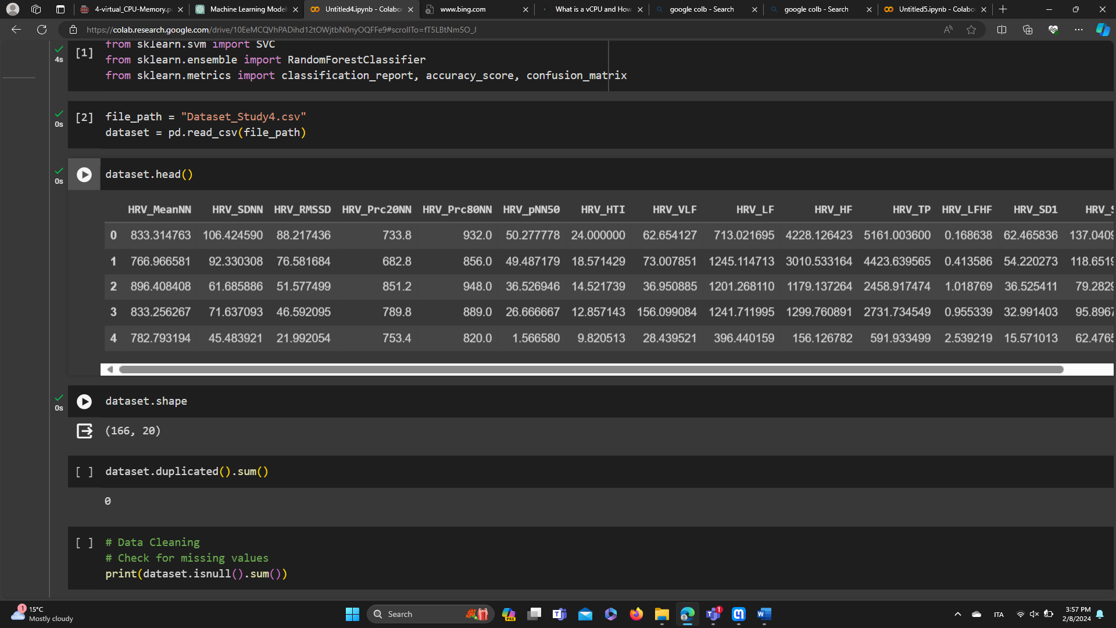

1. Check for duplicated rows

The dataset.duplicated().sum() code is checking for and counting the number of duplicated rows in your dataset.

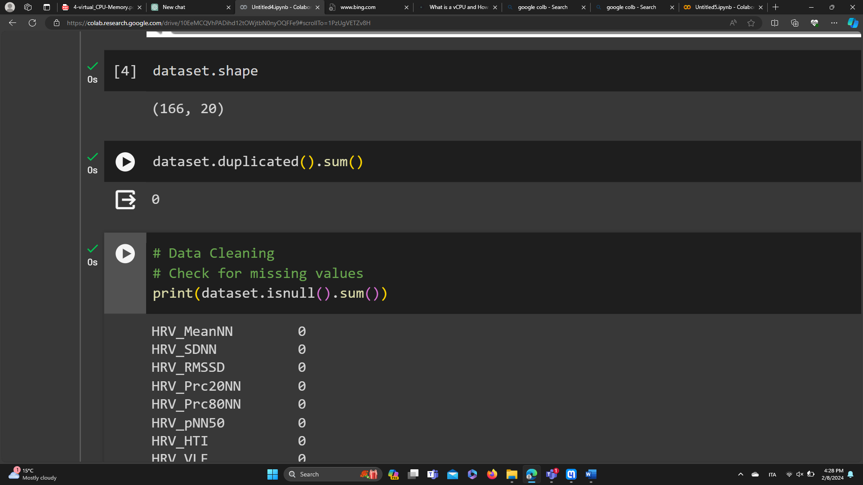

1. Check for missing values

This part checks for missing values in the dataset using isnull().sum() and prints the count of missing values for each column.

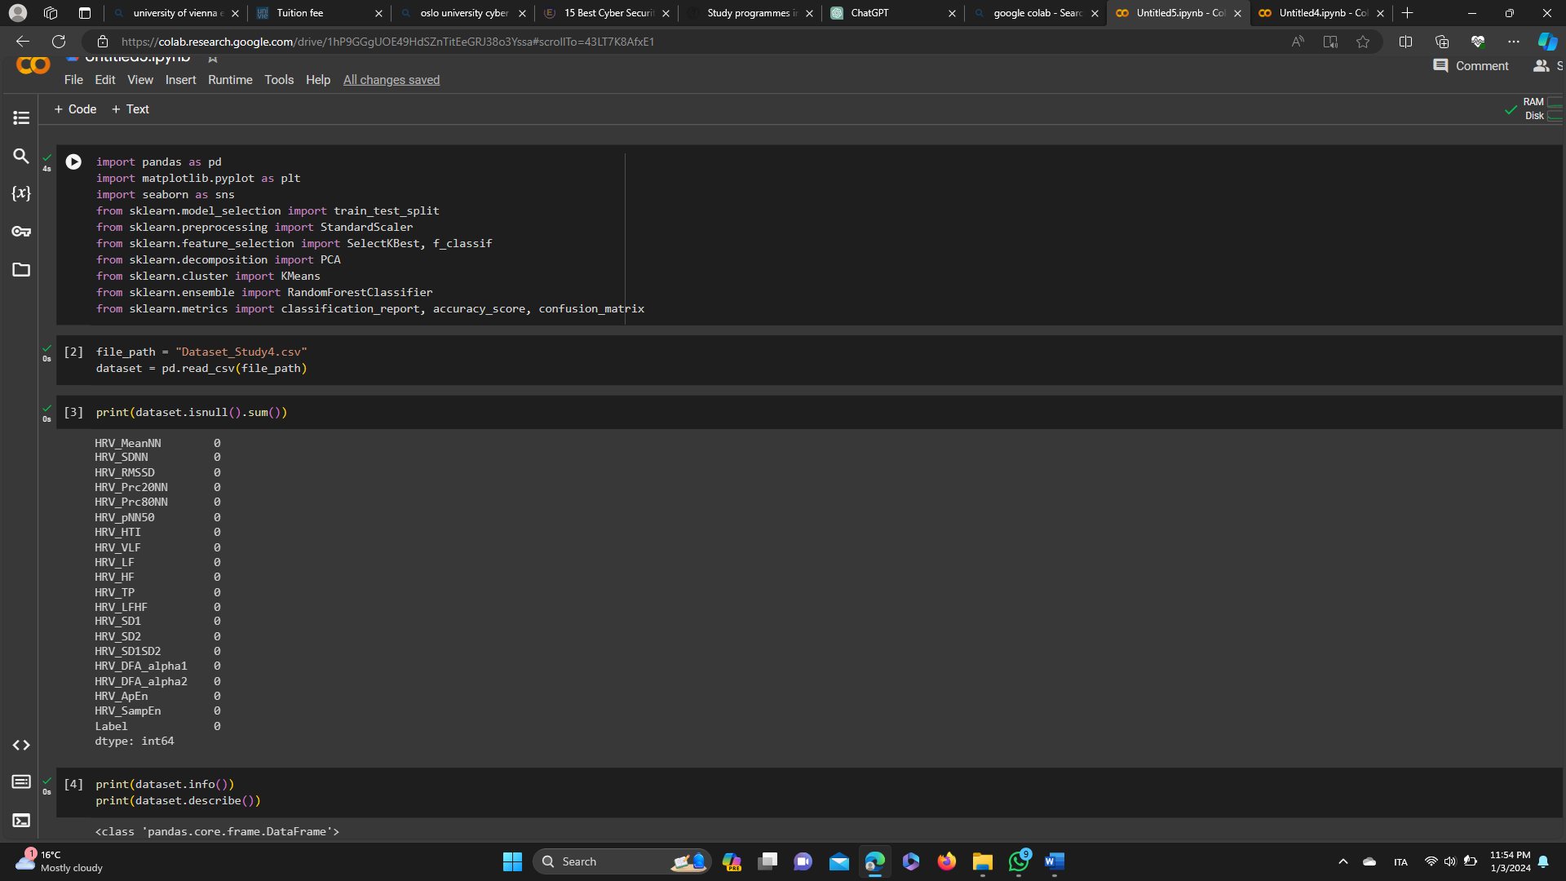

1. Explore the dataset

dataset.describe() provides a concise summary of the dataset, including the number of non-null values and data types for each column and total memory usage of the DataFrame. It helps you understand the distribution and variability of your numerical features.

dataset.info() provides summary statistics for numerical columns in your dataset, such as mean, standard deviation, minimum, 25th percentile, 50th percentile(median), 75th percentile, and maximum values. It helps you understand the distribution and variability of your numerical features.

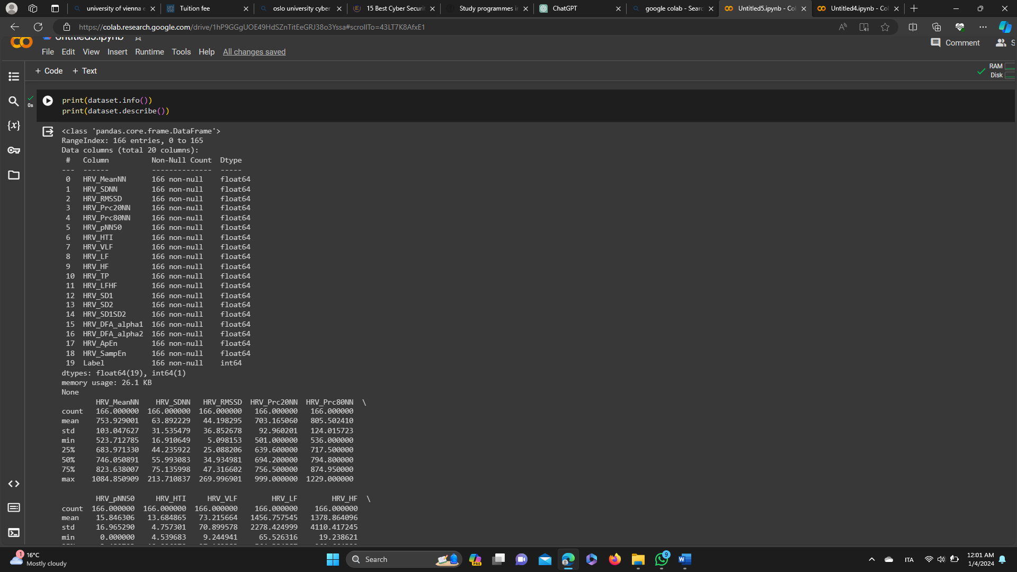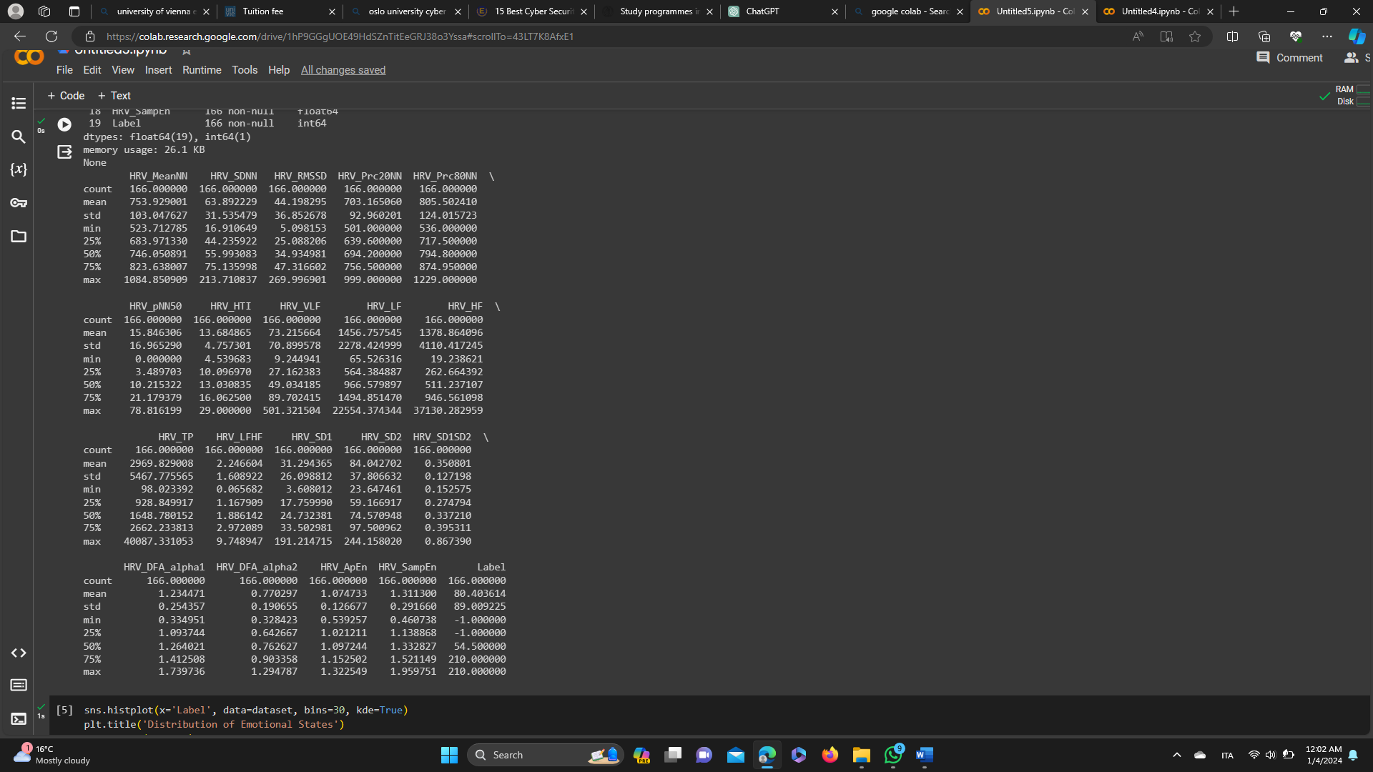

1. Visualize the distribution of the 'Label' column

This code snippet is using the Seaborn library to create a histogram plot to visualize the distribution of emotional states in your dataset.

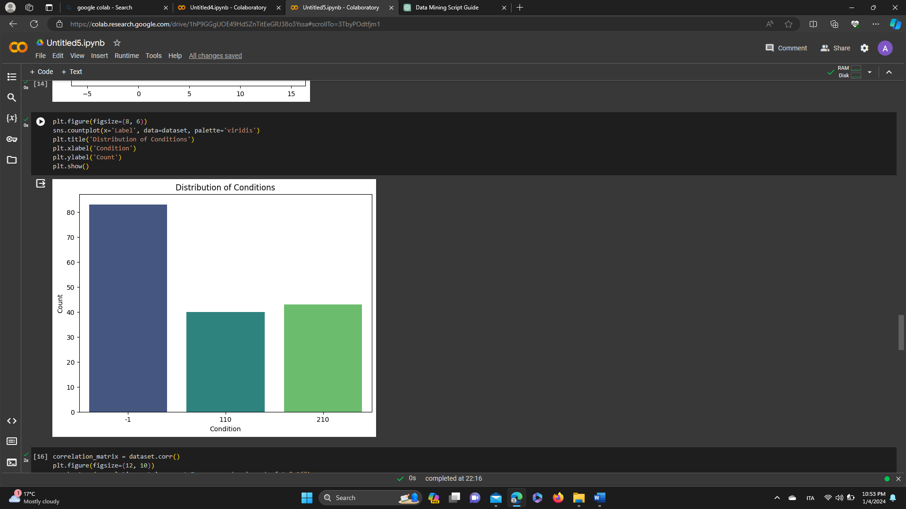

1. Explore correlations between features

This section generates a heatmap to visualize the correlation matrix of features in the dataset.

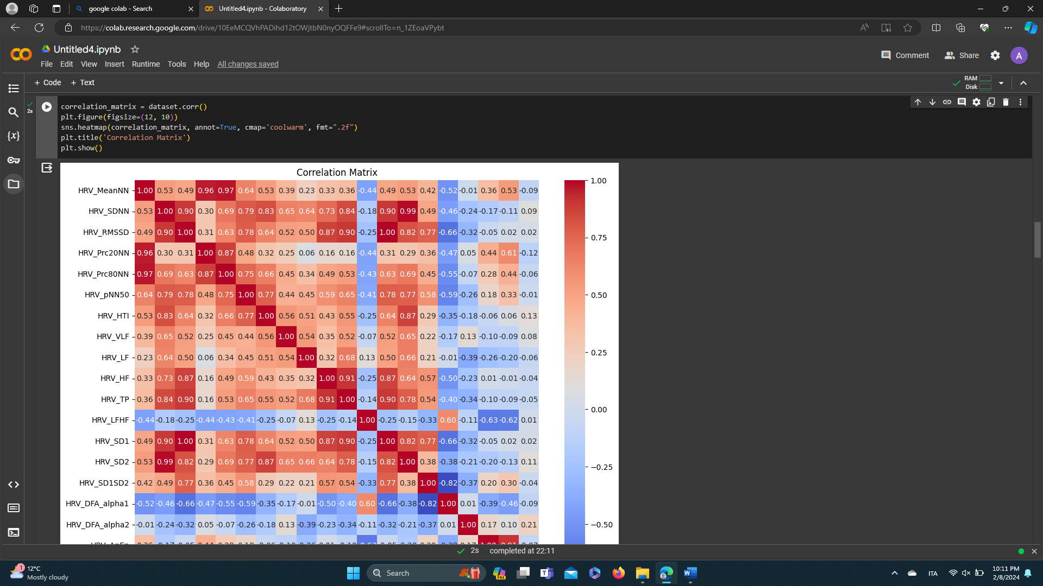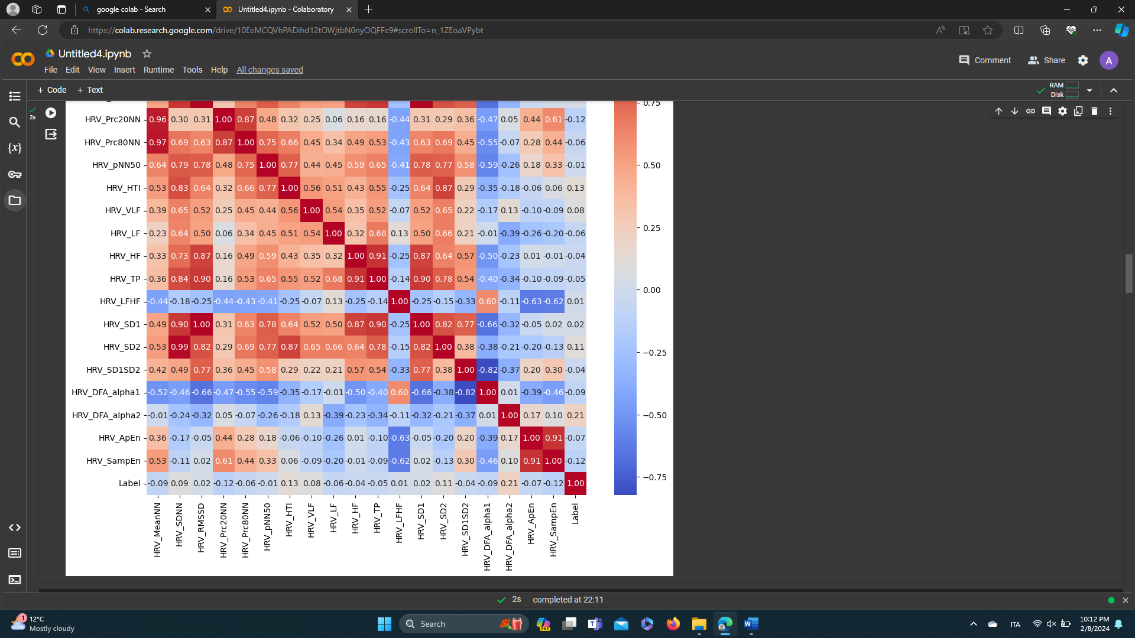

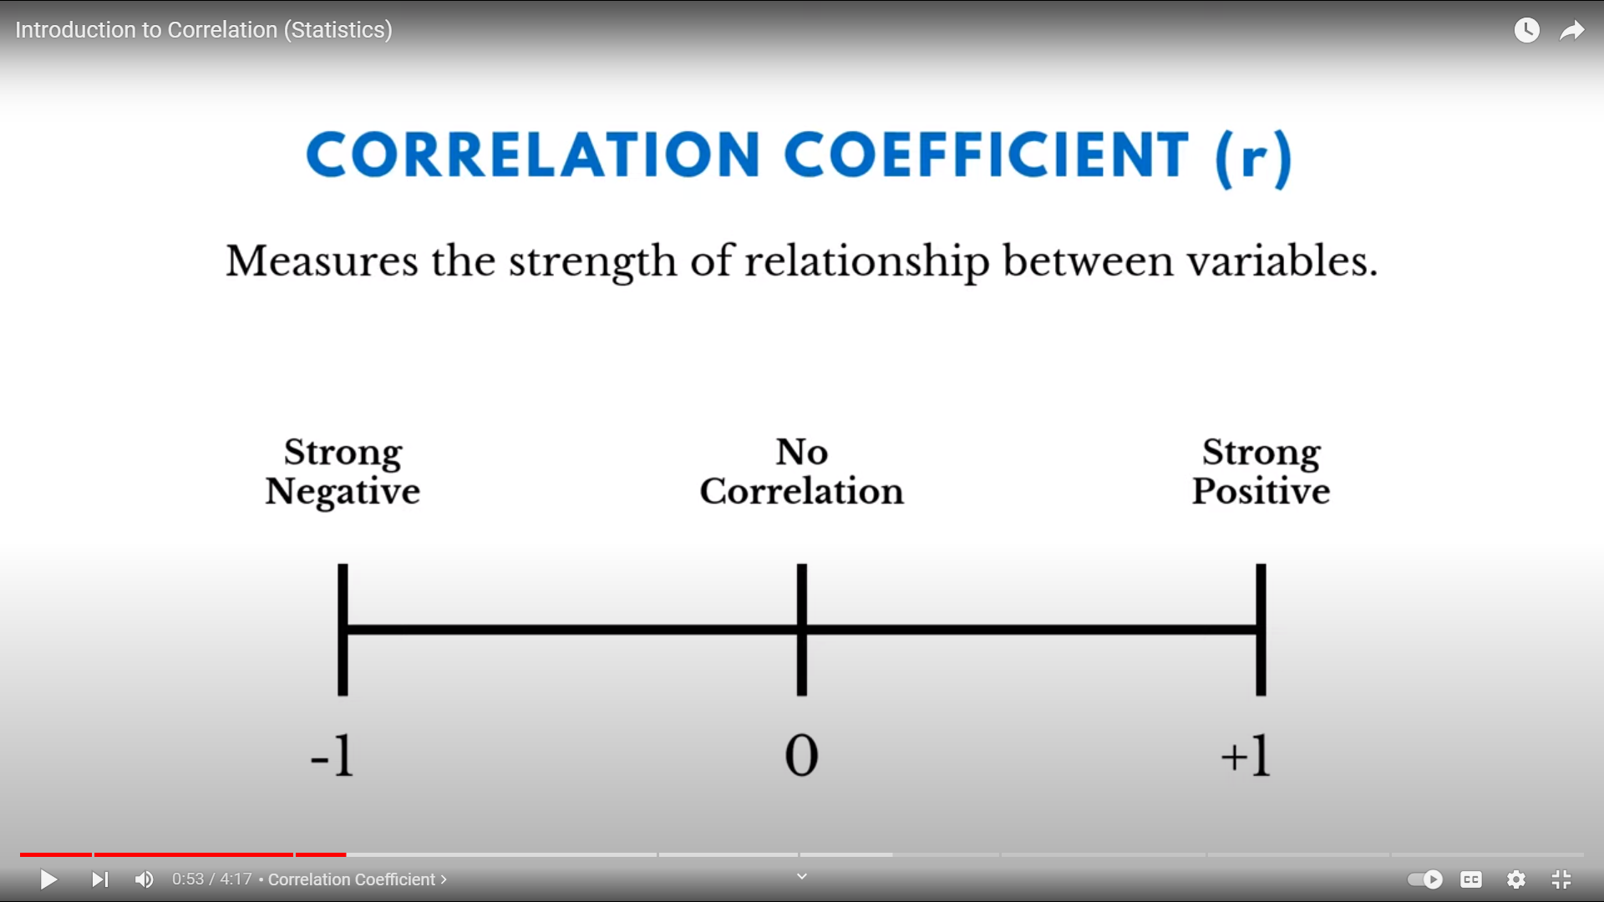

Positive correlations suggest that the variables tend to move together, while negative correlations suggest an inverse relationship between the variables.

1. Visualize relationships between features and emotional states

Here, a pair plot is generated using seaborn to visualize relationships between features in the dataset, with different emotional states distinguished by color.

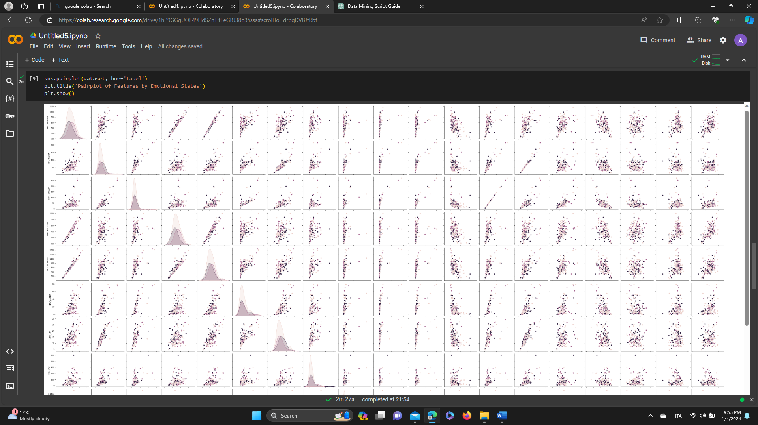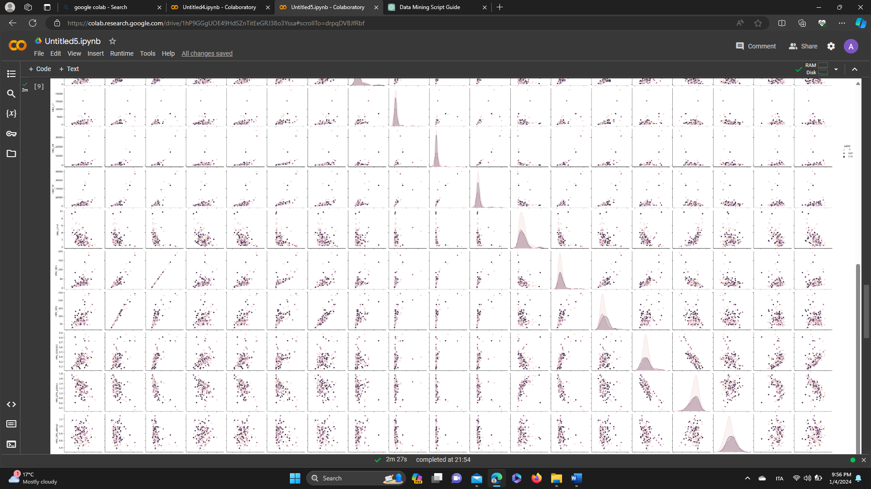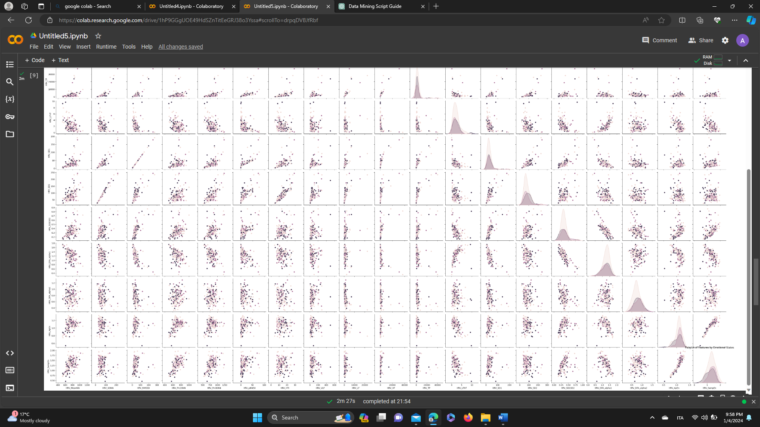Top of Form

1. Separate features and labels

This part separates features (X) and labels (y) from the dataset. The target variable is assumed to be named 'Label.'

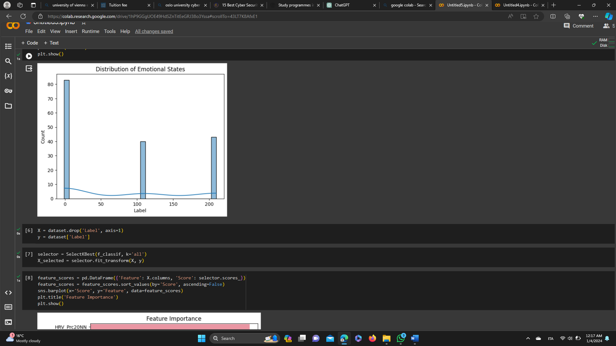

* X: a DataFrame containing only the feature columns (all columns except 'Label').
* y: a Series containing the labels (the 'Label' column).

This separation is essential for training machine learning models, as the features (X) are used as inputs to the model, while the labels (y) are the target outputs that the model will learn to predict.

1. Standardization

The StandardScaler in scikit-learn is used for standardizing features by removing the mean and scaling them to unit variance.

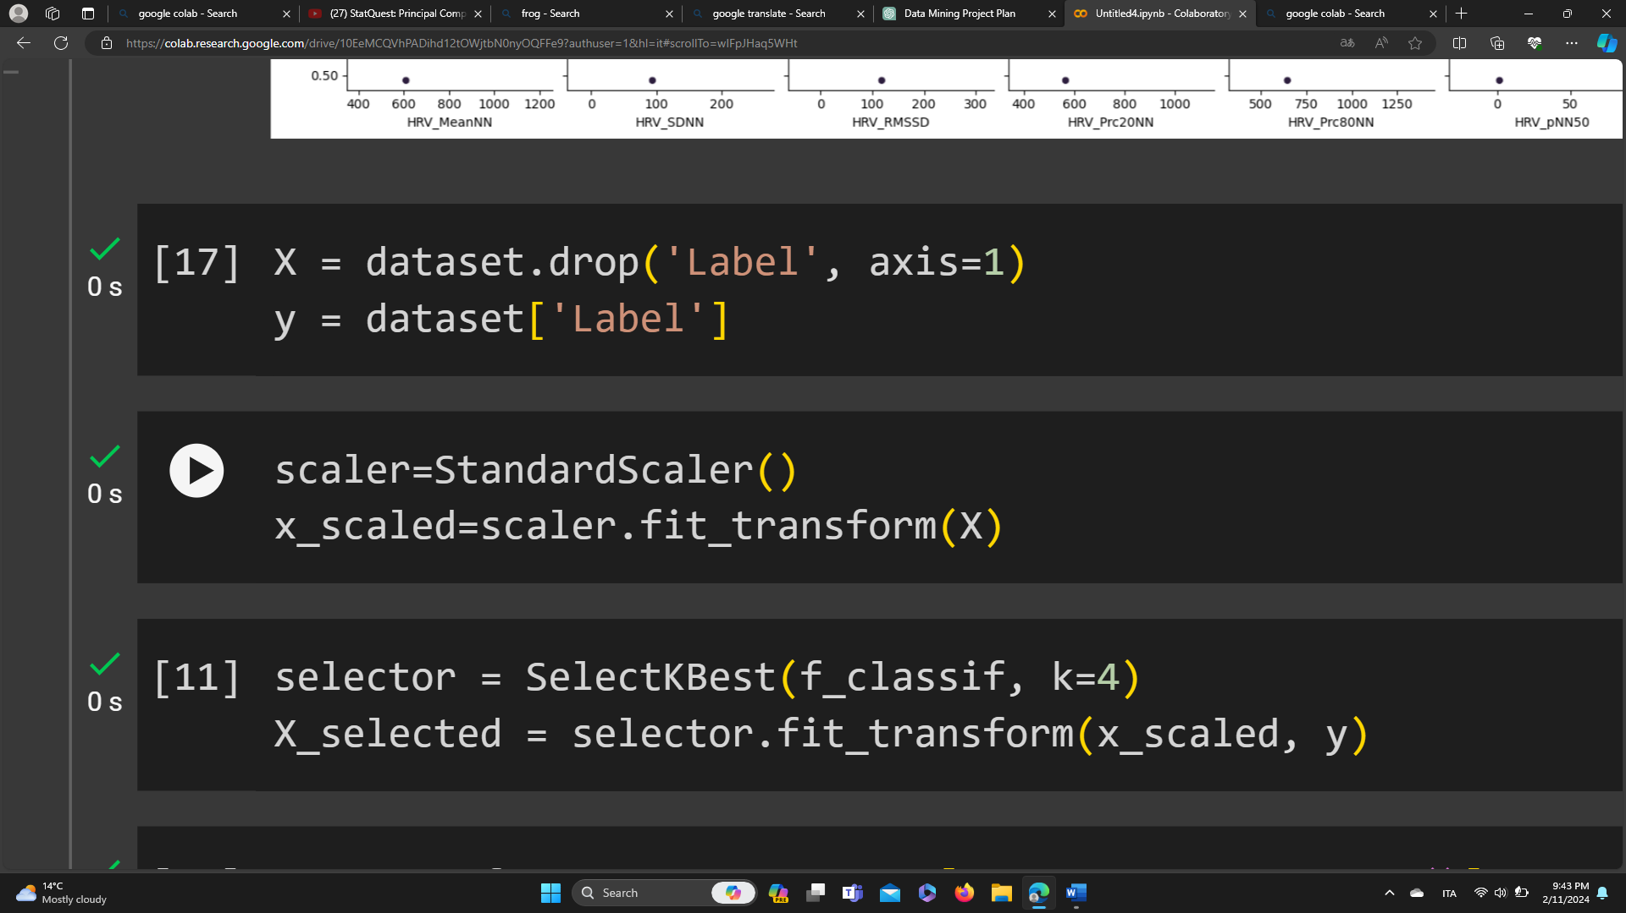

1. Feature selection

select the top 4 features based on their importance scores obtained from the ANOVA F-value test (f_classif). These selected features are considered the most informative for predicting the target variable (emotional states) in the classification task.

and returns a new array X_selected containing only these selected features.

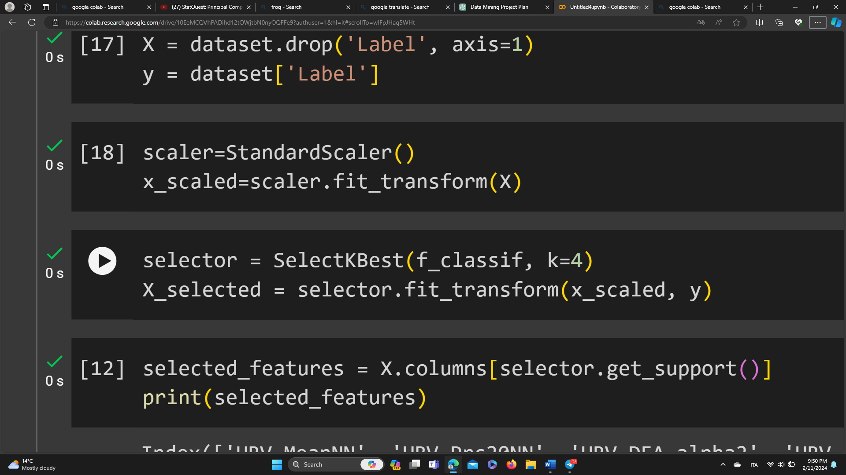

1. Visualize feature importance

This section creates a bar plot to visualize the importance scores of features obtained from the ANOVA F-statistic.

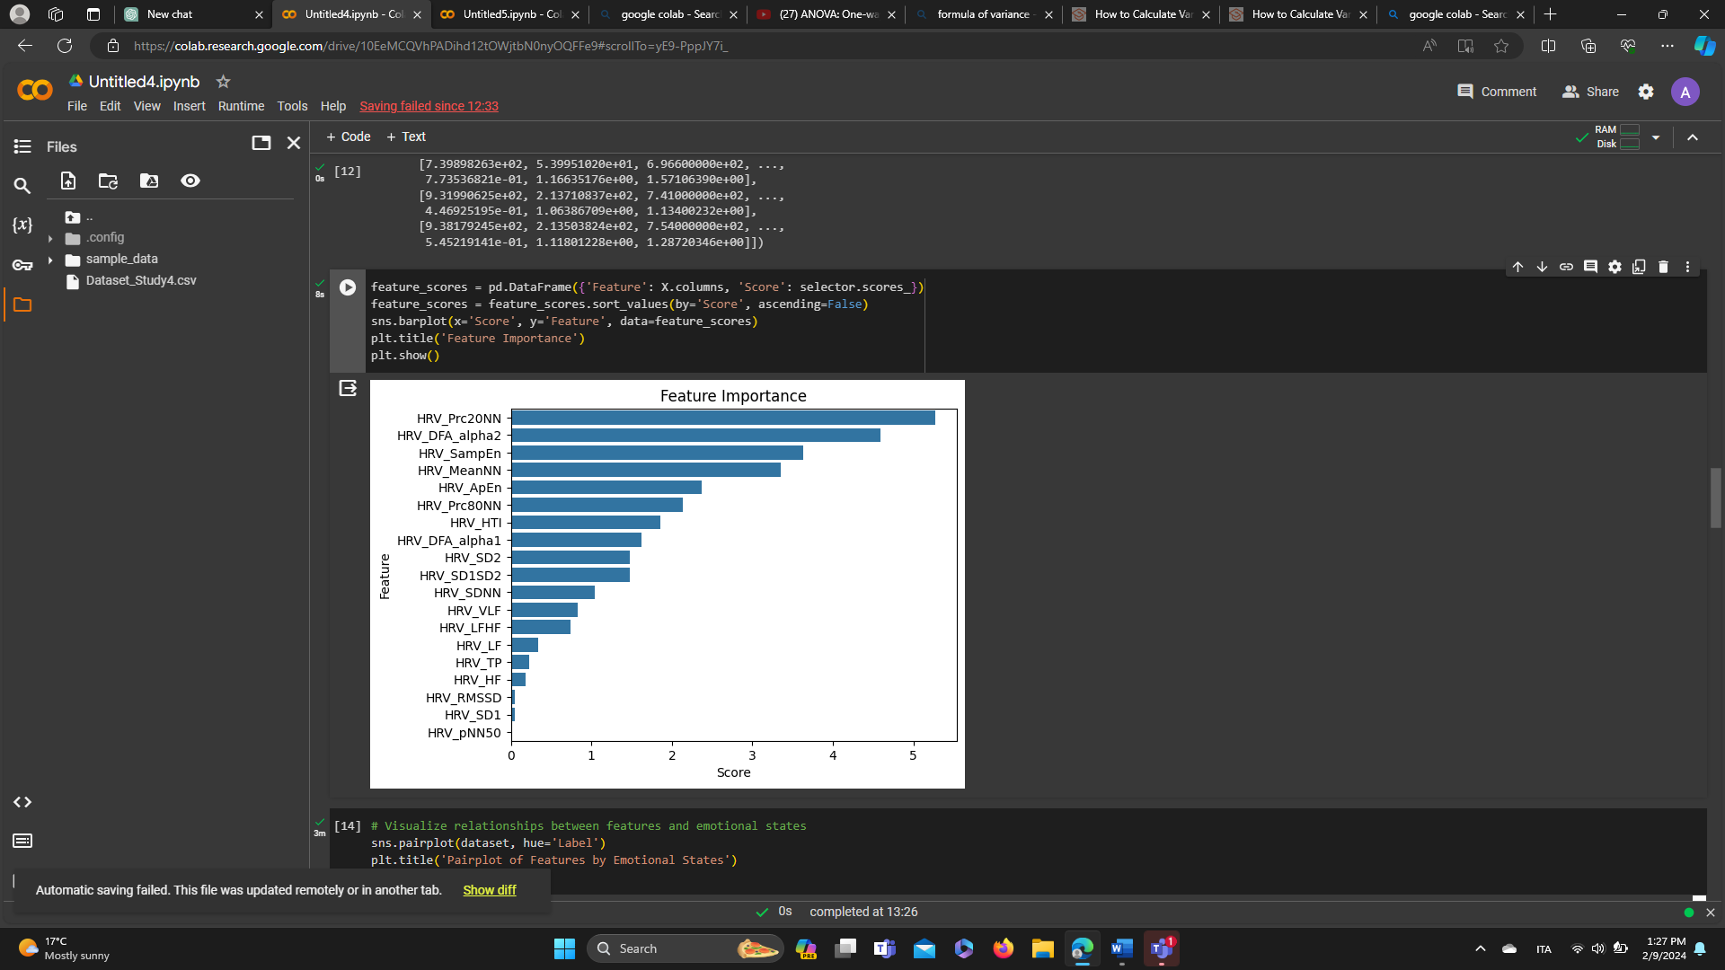

1. Standardize features

This part standardizes the selected features using StandardScaler from scikit-learn.

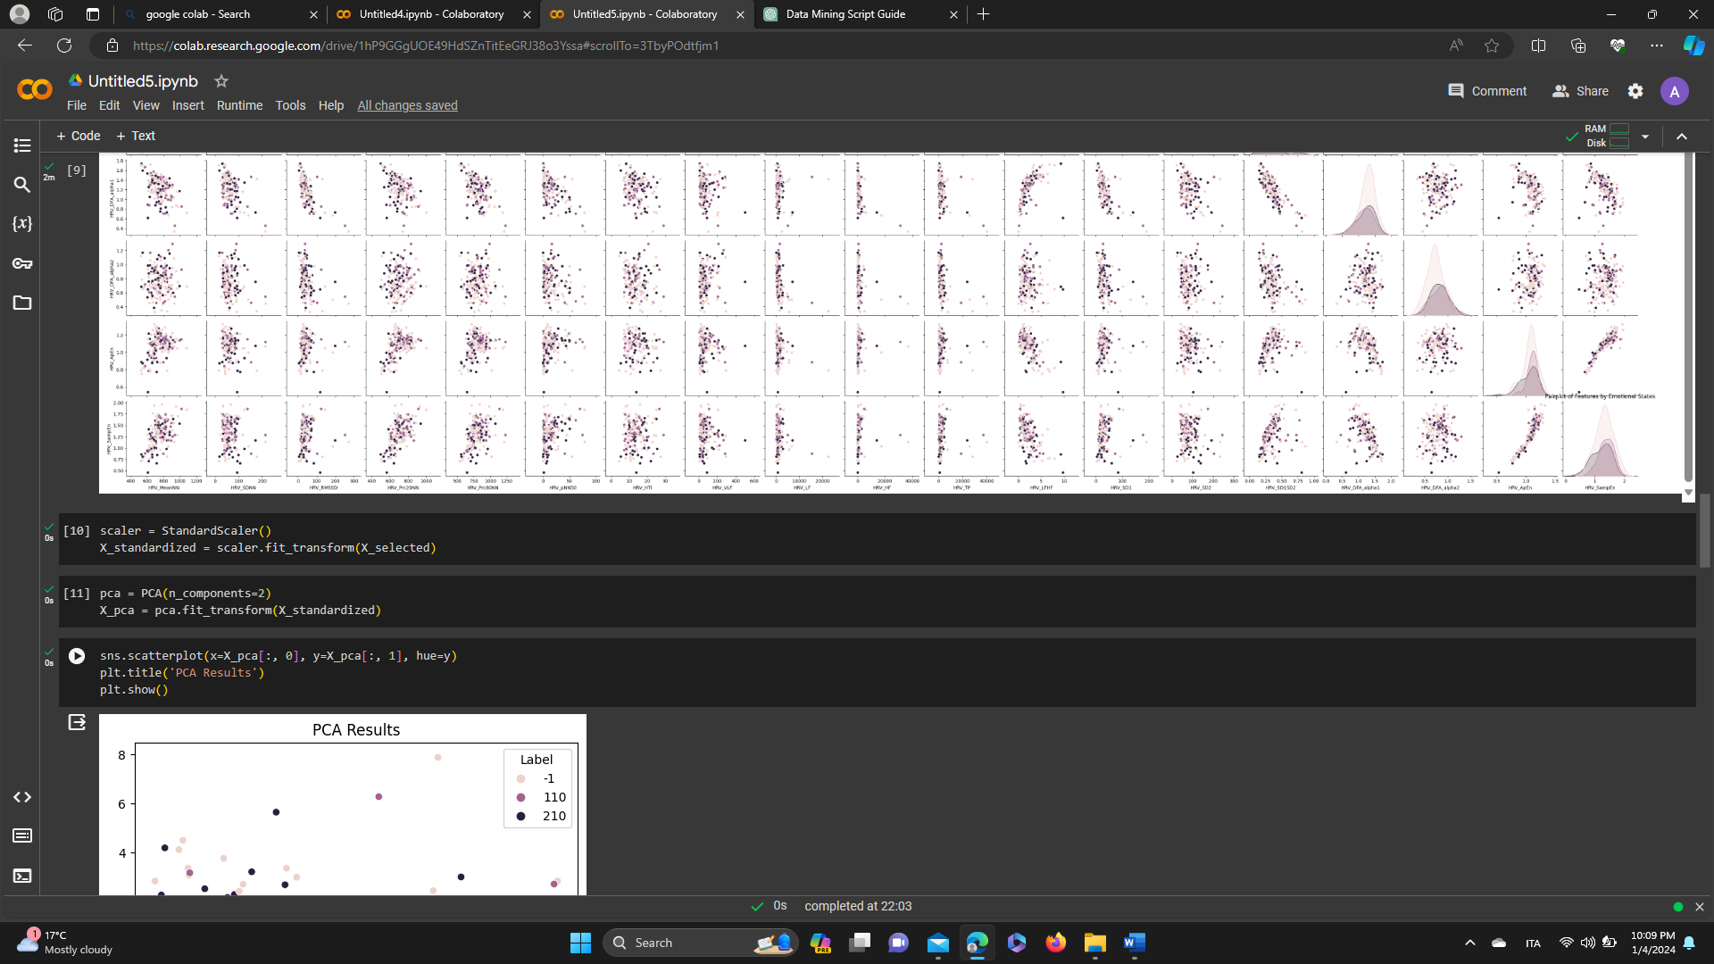

1. Visualize the selected features

The code segment retrieves the names of the selected features after applying the SelectKBest feature selection method.

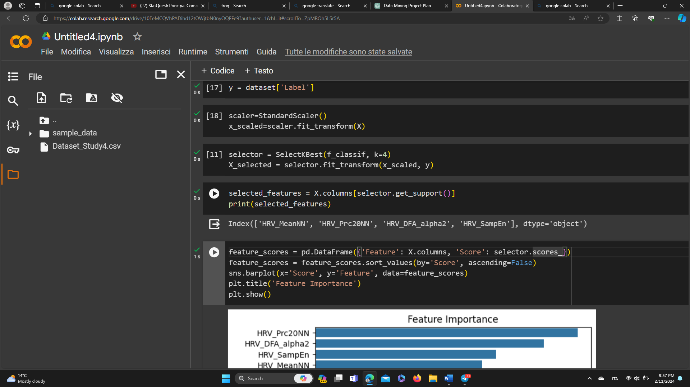

1. Apply PCA to reduce dimensionality.

This line of code performs Principal Component Analysis (PCA) on the standardized data X_scaled to reduce its dimensionality to 3 principal components.

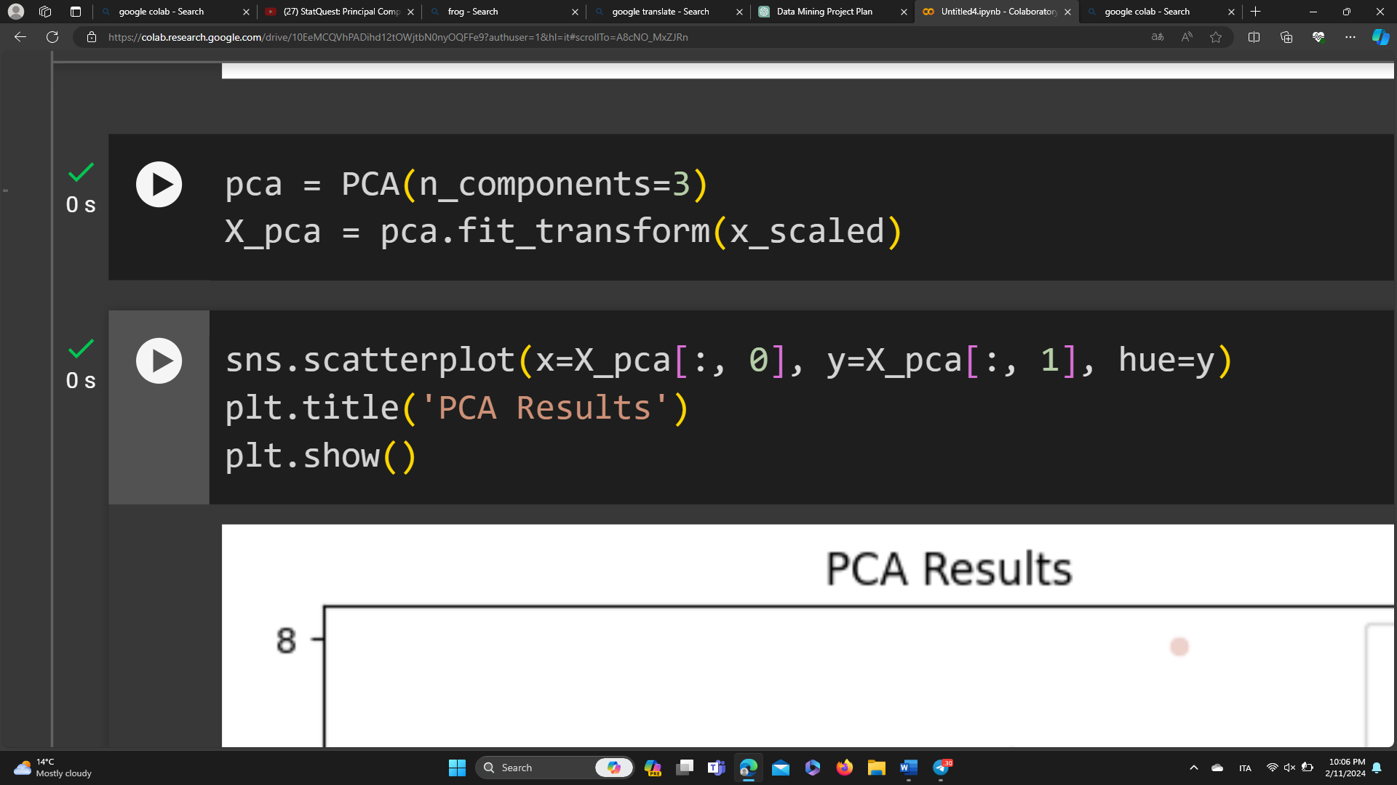

X_pca will contain the transformed data with reduced dimensionality, where each sample is represented by three principal components.

1. Visualize PCA results

This segment generates a scatter plot to visualize the results of PCA, where each point is colored based on the corresponding emotional state.

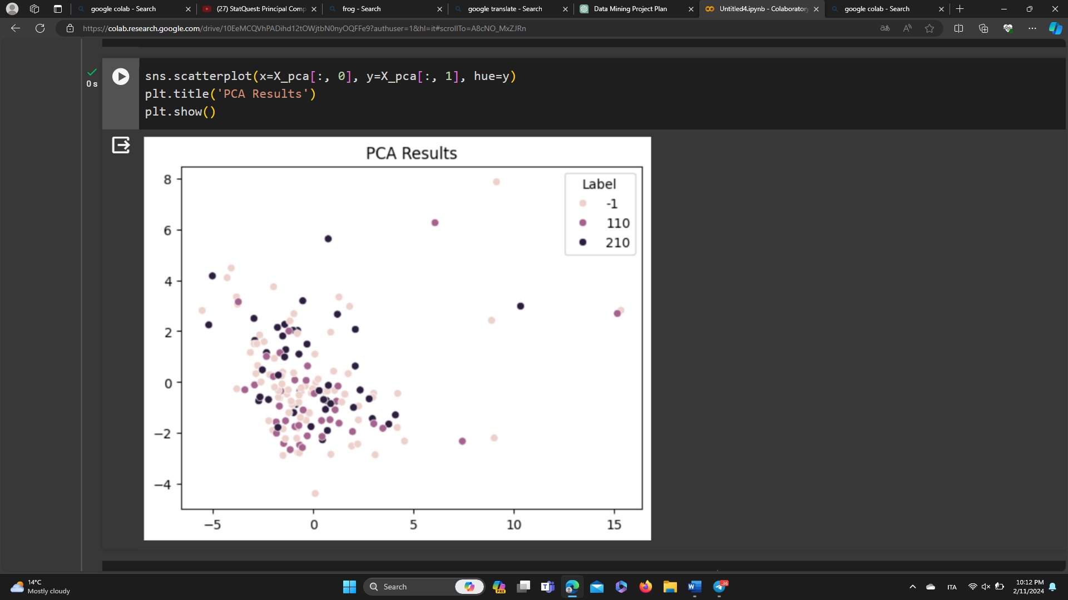

1. Split the dataset into training and testing sets

The dataset is split into training and testing sets using train_test_split from scikit-learn.

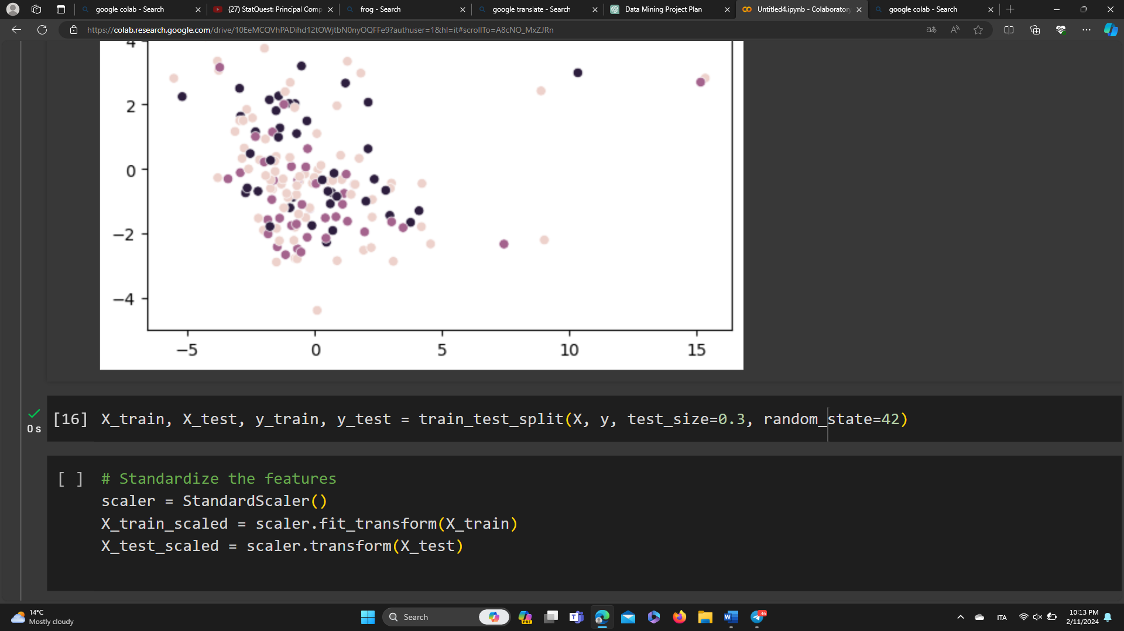

1. Standardize the features

Features in the training and testing sets are standardized using StandardScaler.

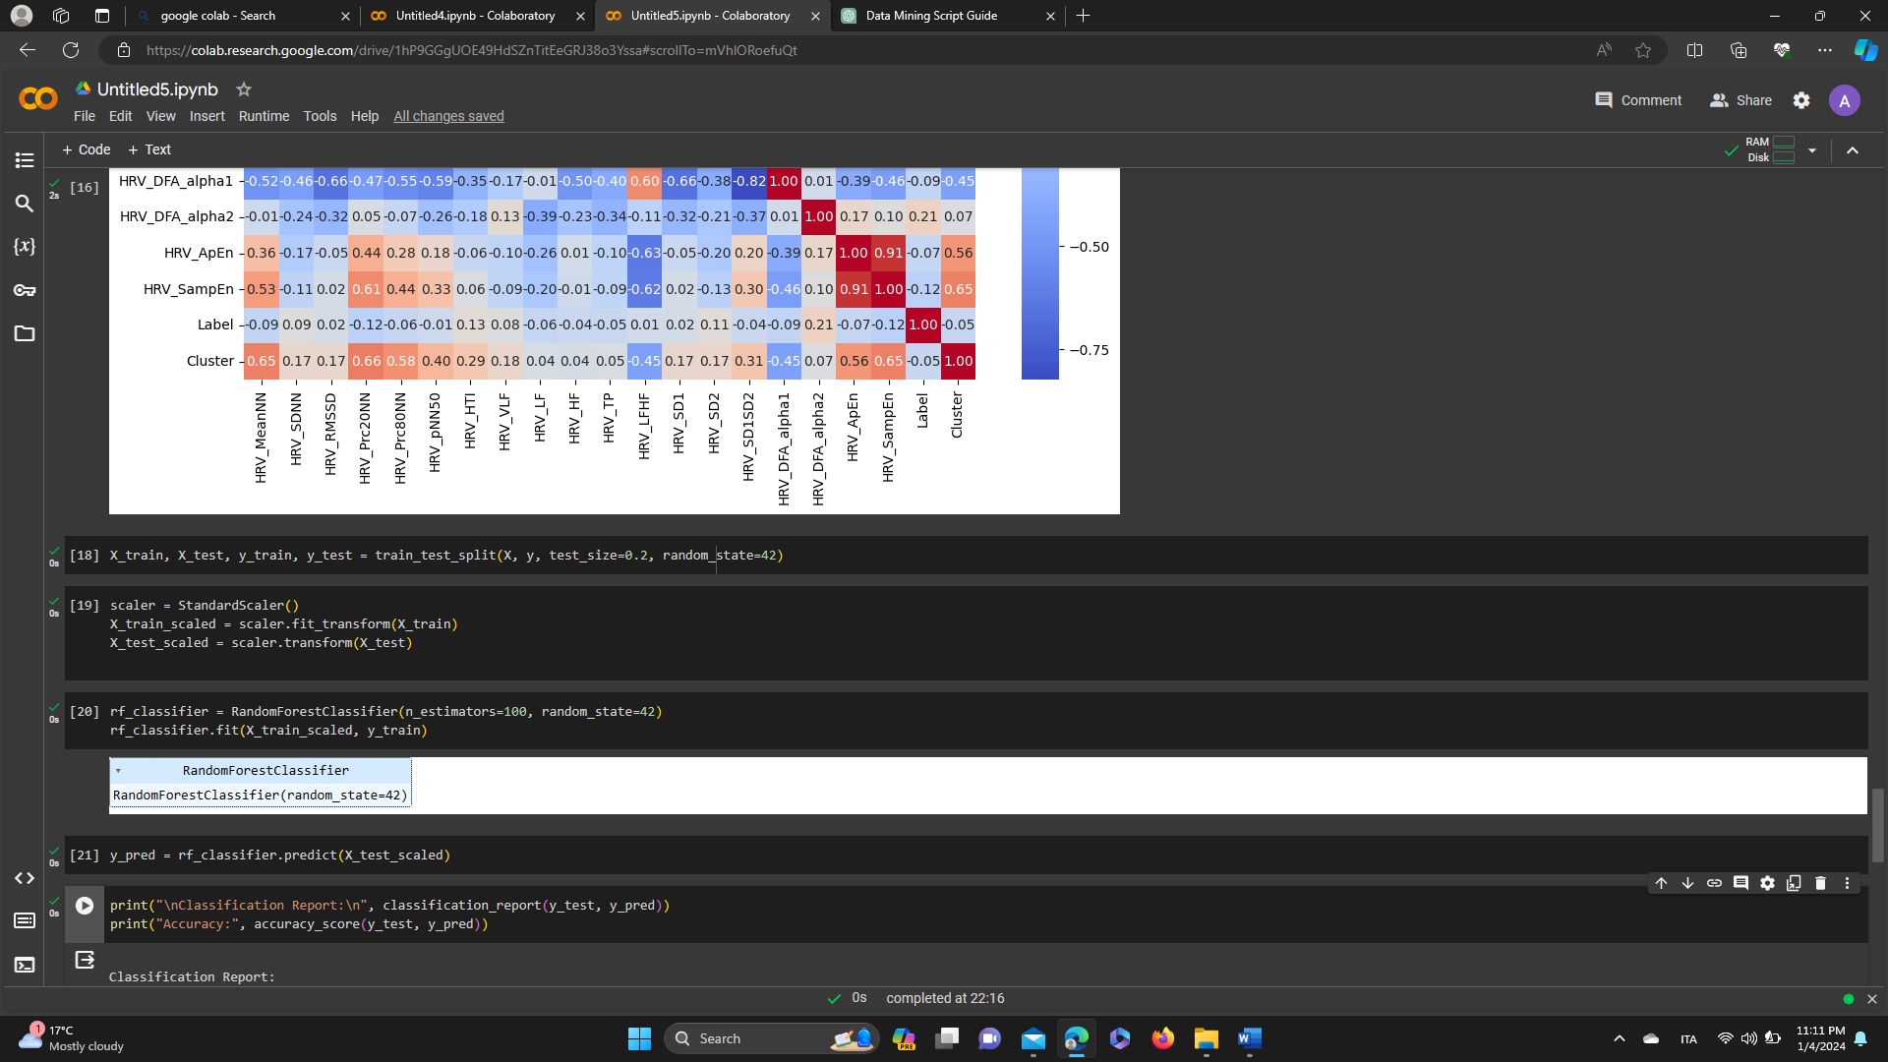

1. Build a Random Forest Classifier

A Random Forest Classifier is instantiated, trained on the scaled training data.

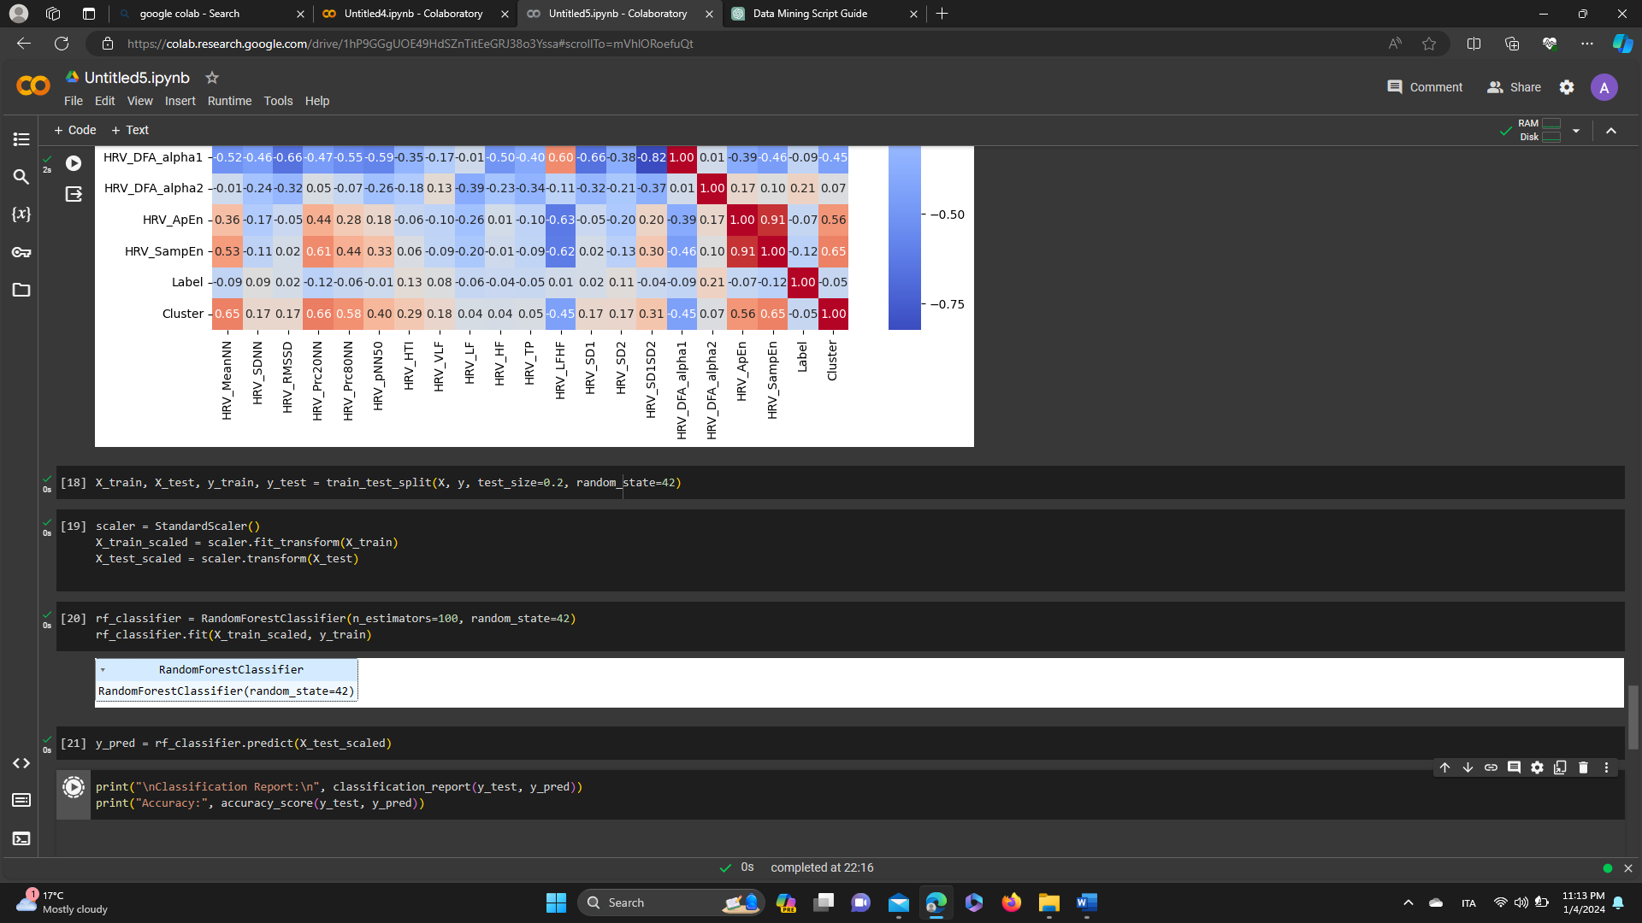

* X_train_scaled is the feature matrix of the training data, where the features have been scaled using StandardScaler.
* y_train is the target variable (labels) corresponding to the training data.

1. Predict on the test set

This line of code predicts the labels for the test set using the trained Random Forest Classifier model.

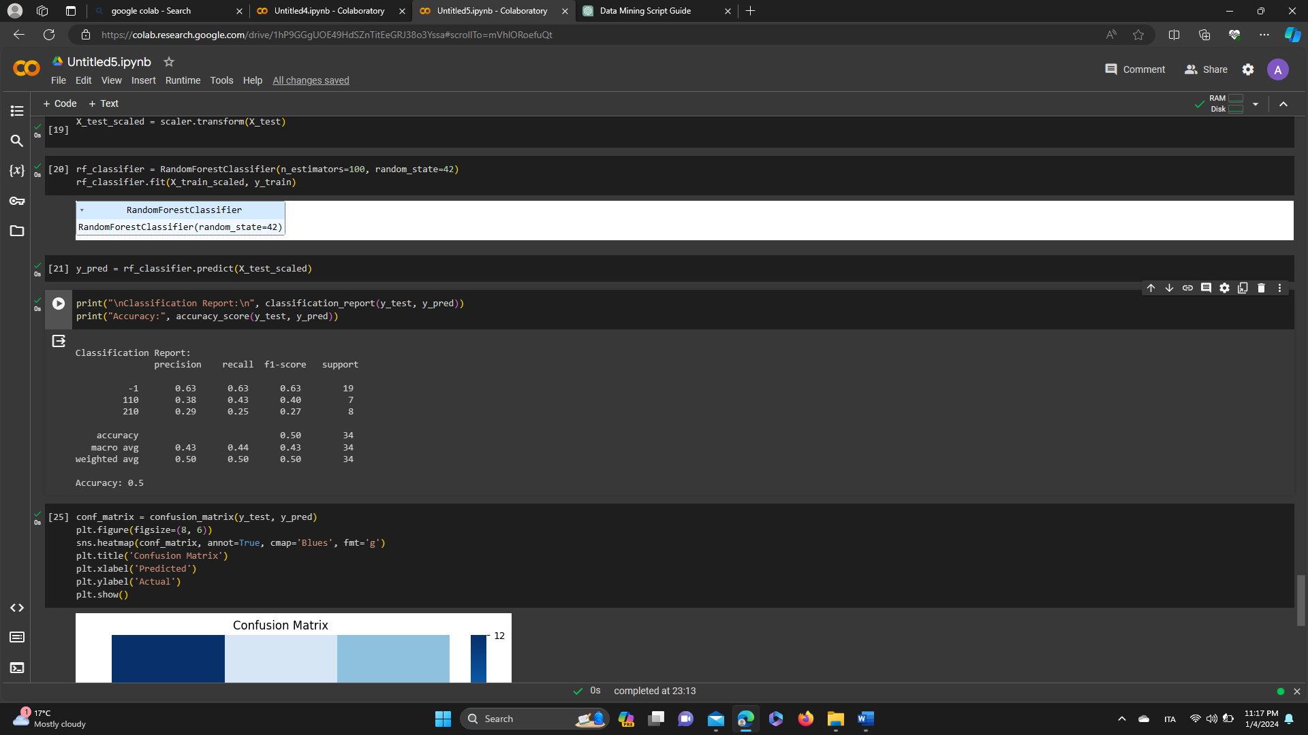

y_pred will contain the predicted labels for the test set based on the input features X_test_scaled

1. Evaluate the model

This segment prints the classification report and accuracy score to evaluate the performance of the Random Forest Classifier on the test set. The classification report provides metrics such as precision, recall, and F1-score for each class.

It compares the true labels (y_test) to the predicted labels (y_pred) and computes these metrics for each class.

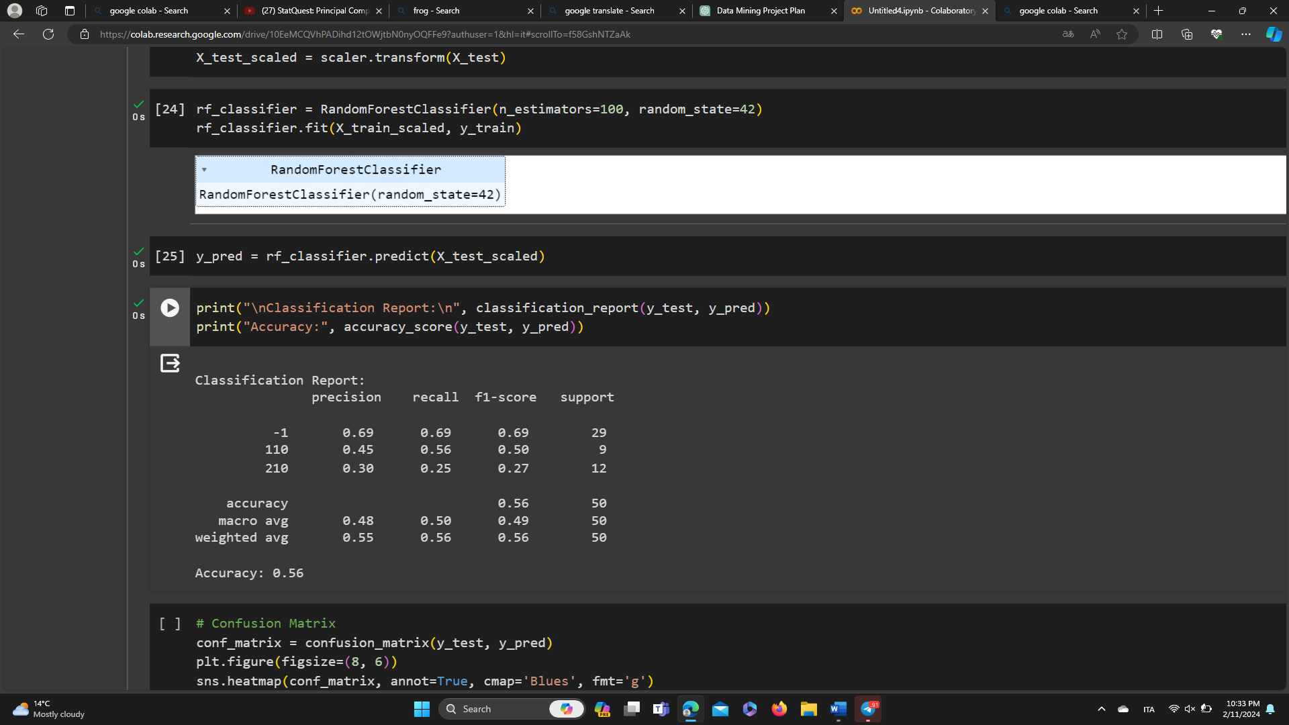

1. Confusion Matrix

This segment computes the confusion matrix using confusion_matrix from scikit-learn and visualizes it as a heatmap using seaborn. The confusion matrix helps assess the model's performance in terms of true positives, true negatives, false positives, and false negatives for each class.

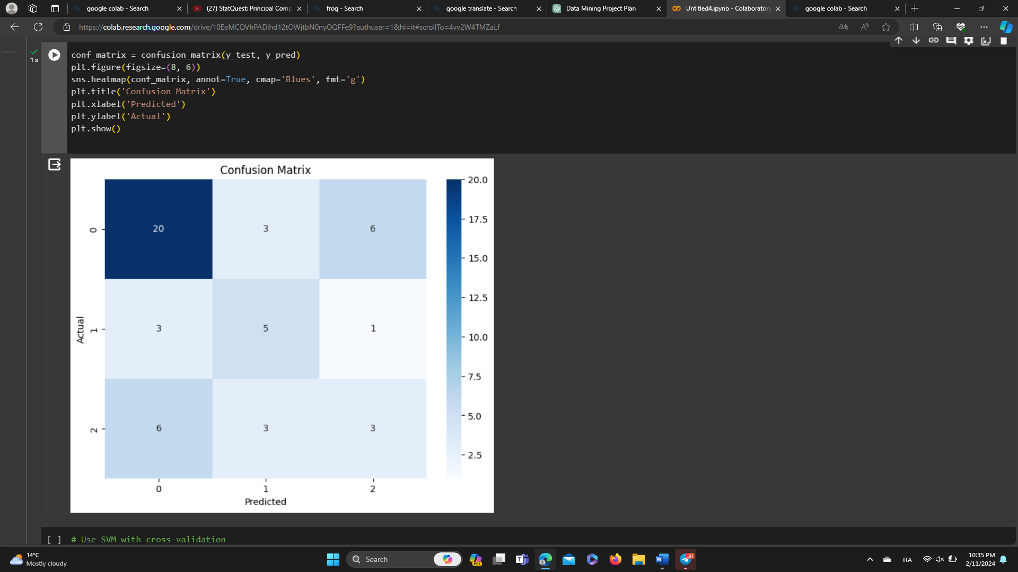

1. Use SVM with cross-validation

Initialize a Support Vector Machine (SVM) classifier with a linear kernel

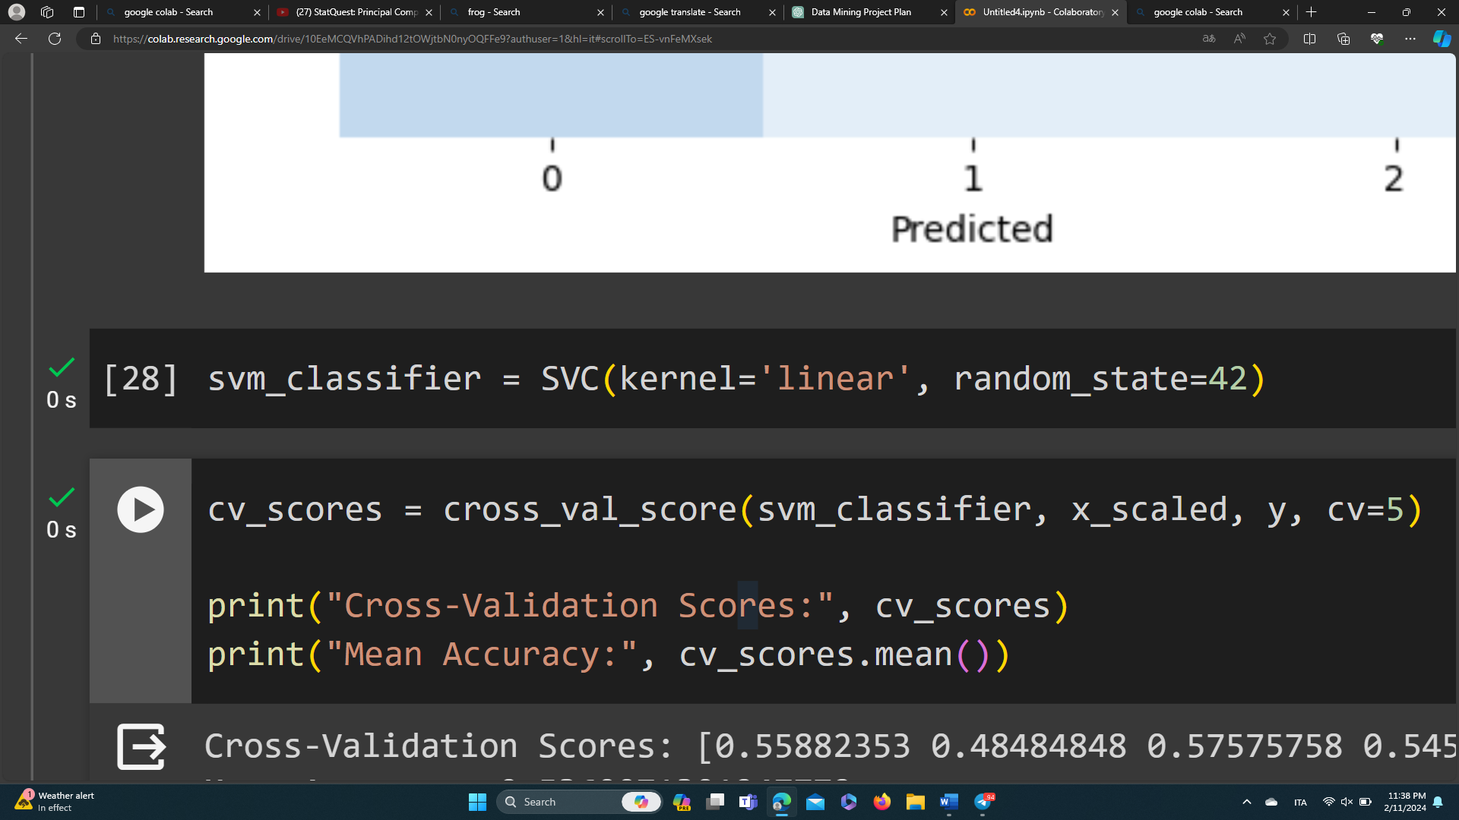

1. Perform cross-validation using X_standardized

cross_val_score is a function from scikit-learn that performs cross-validation by splitting the dataset into 'cv' (here, 5) consecutive folds. Each fold is then used once as a validation while the k - 1 remaining folds form the training set.

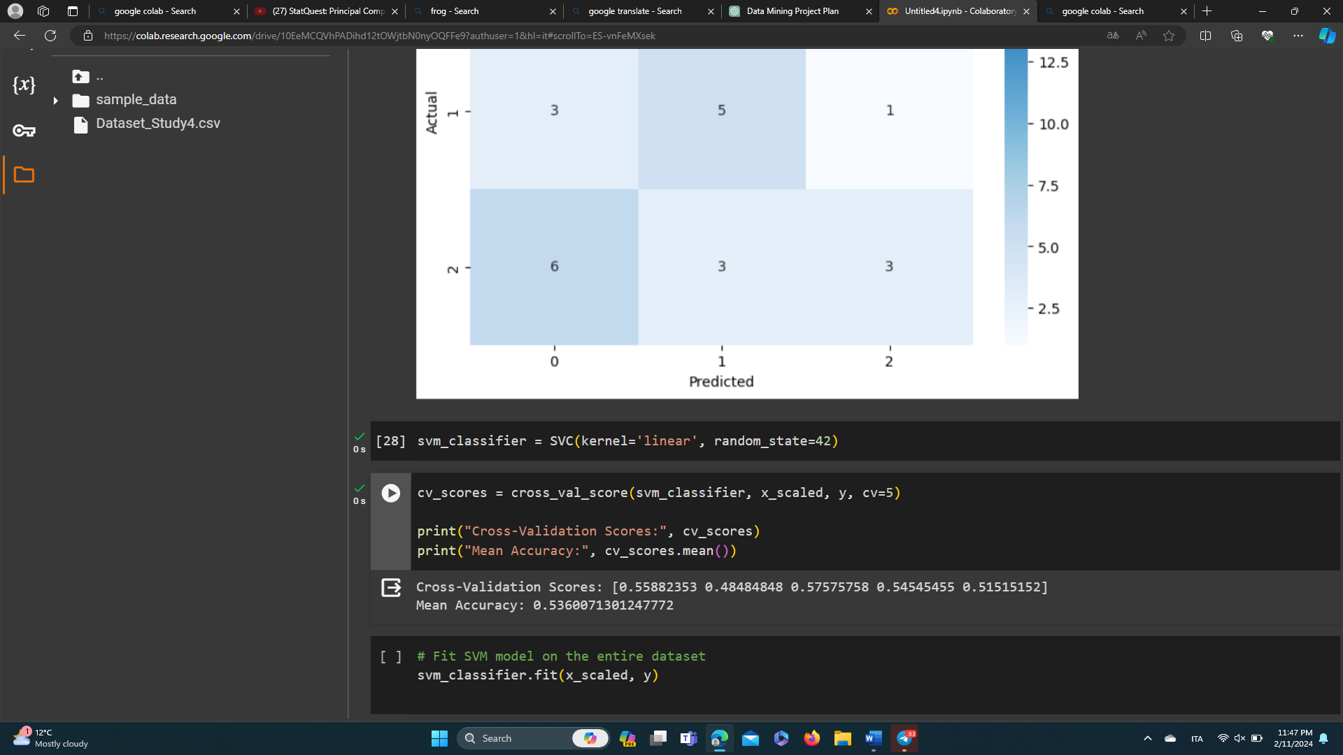

1. Fit SVM model on the entire dataset

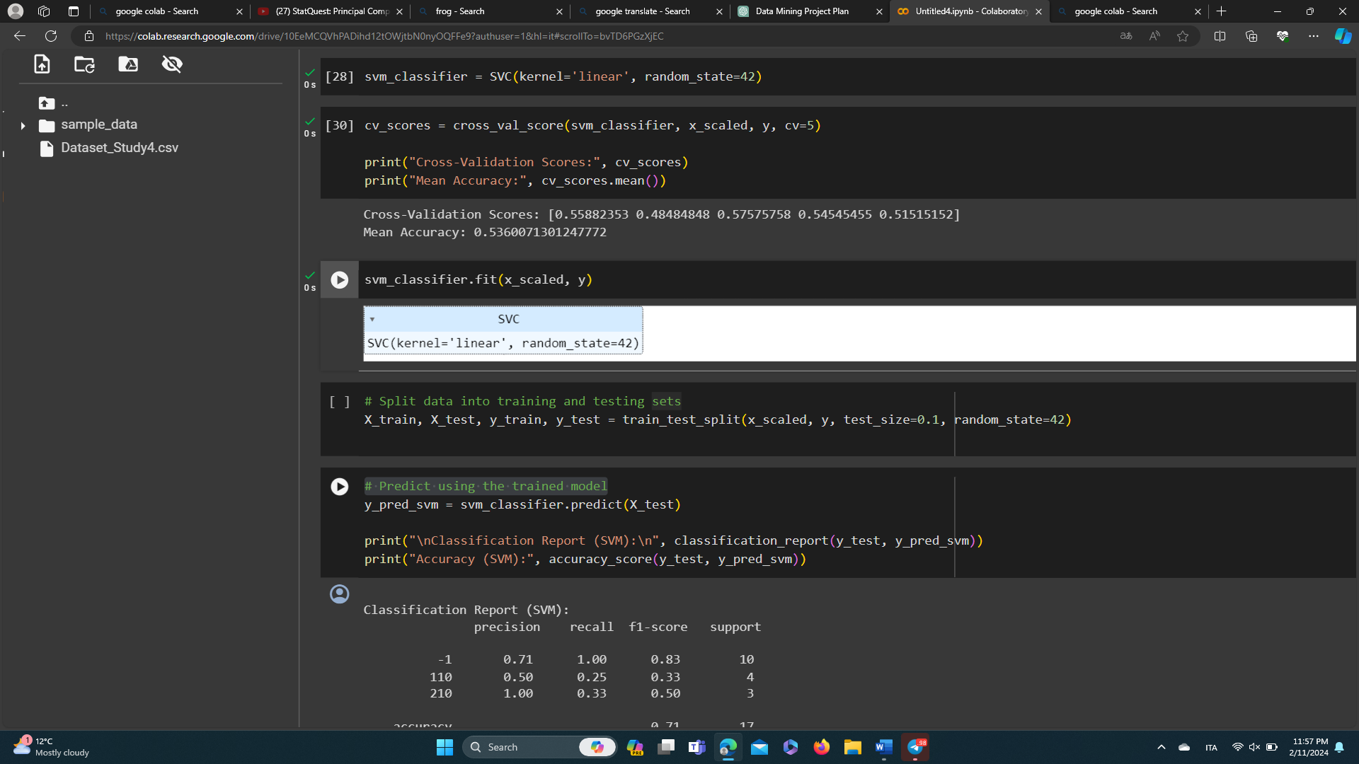

1. Split data into training and testing sets

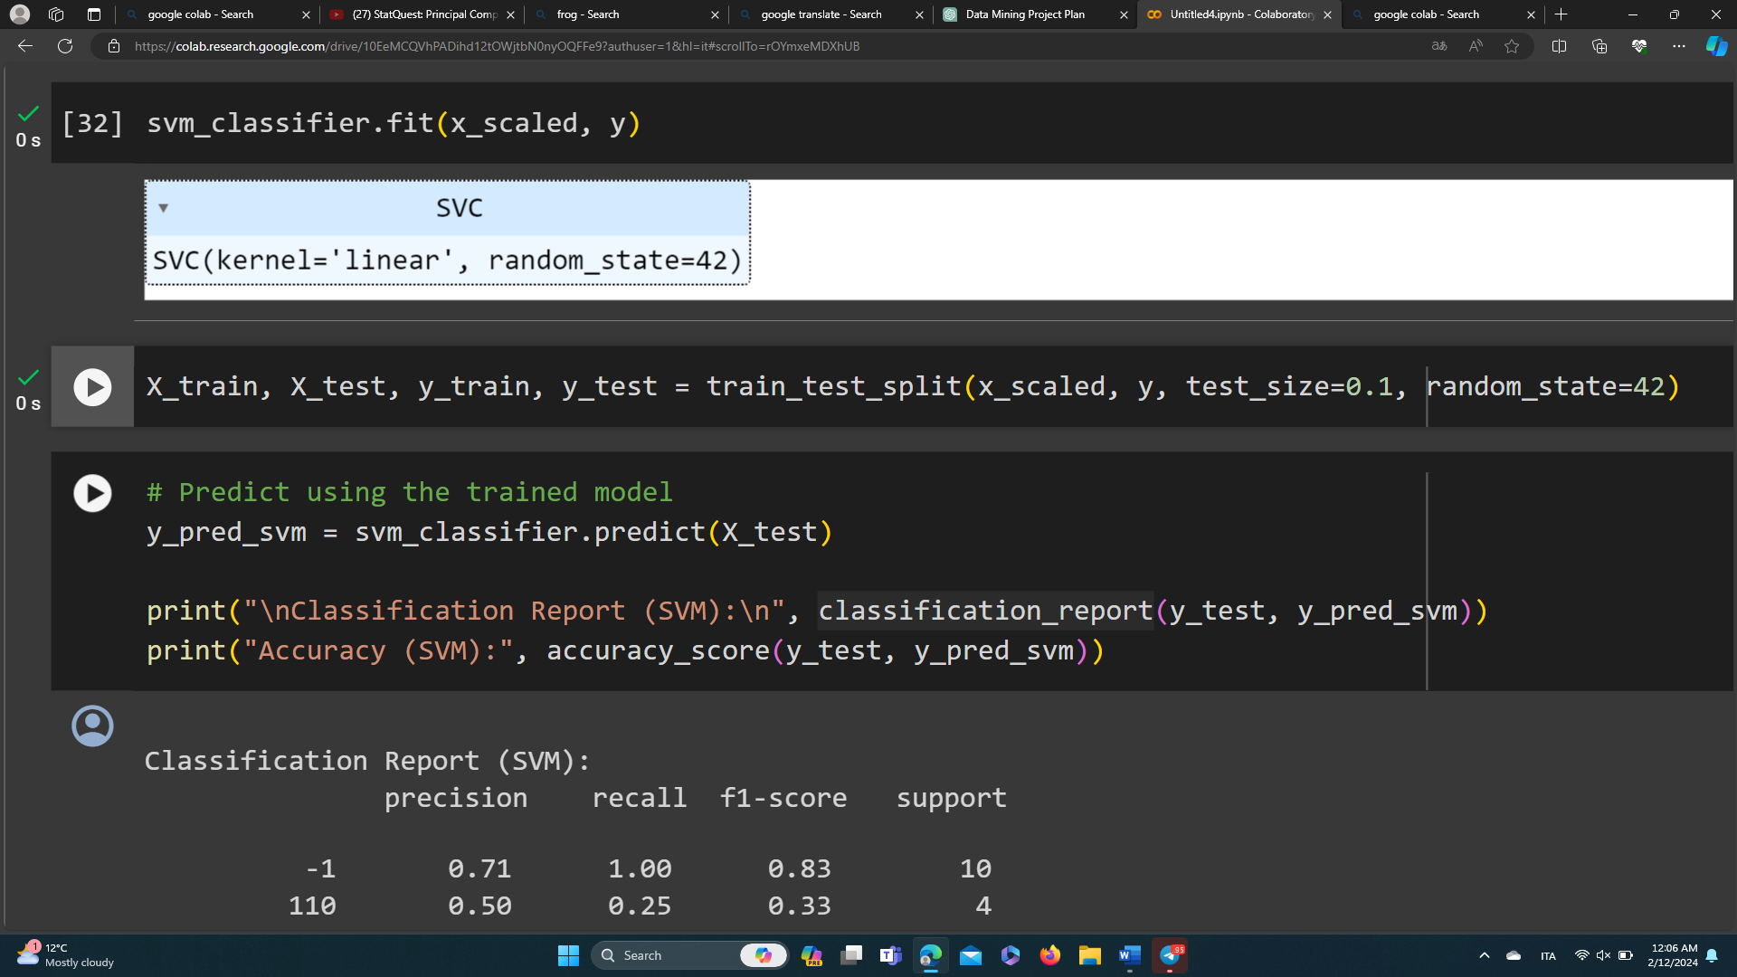

1. Predict using the trained model

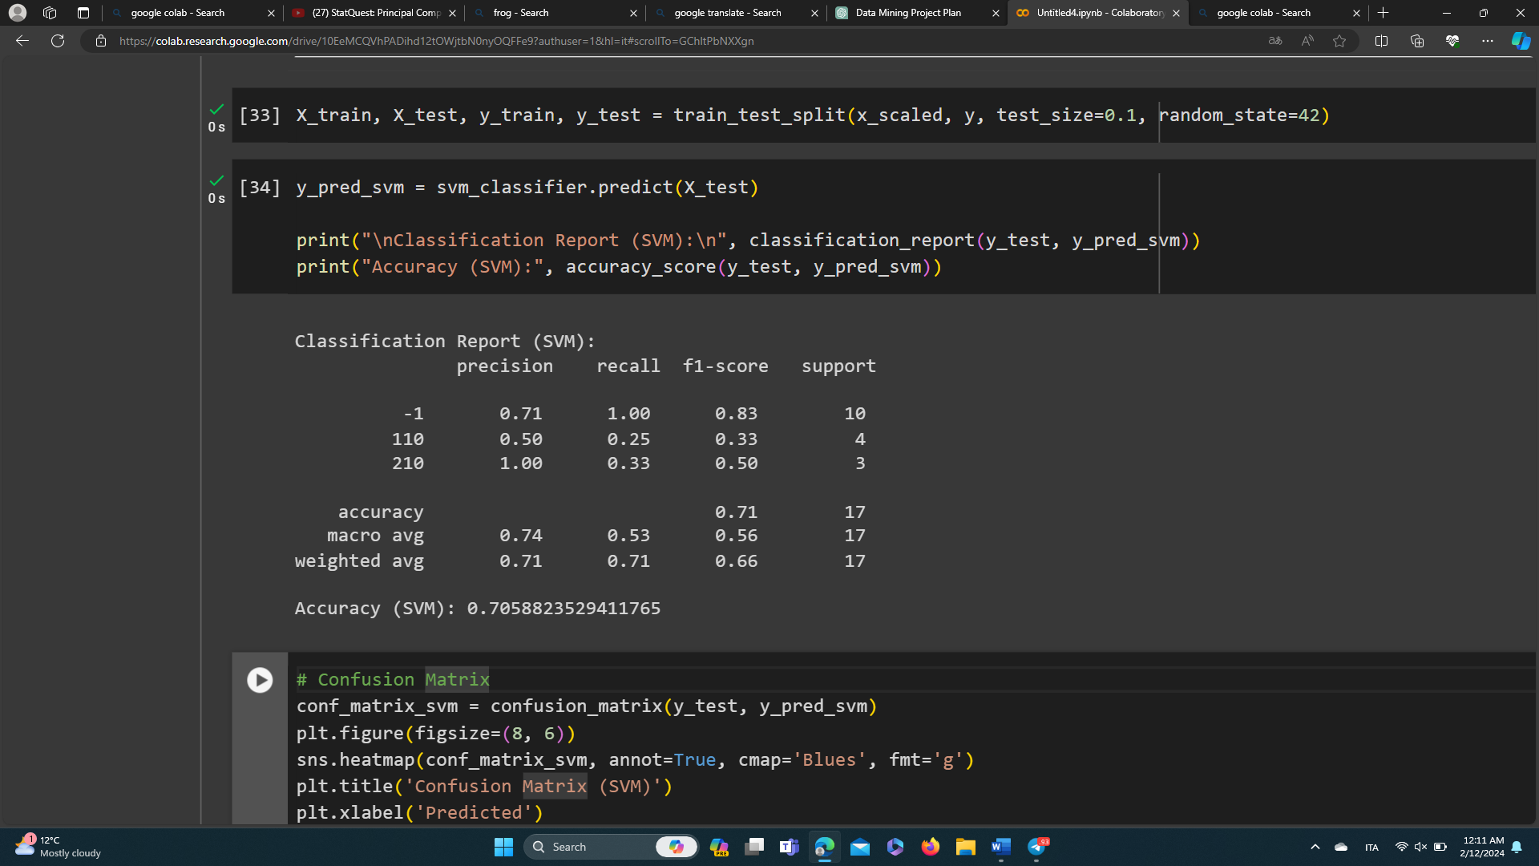

1. Confusion Matrix

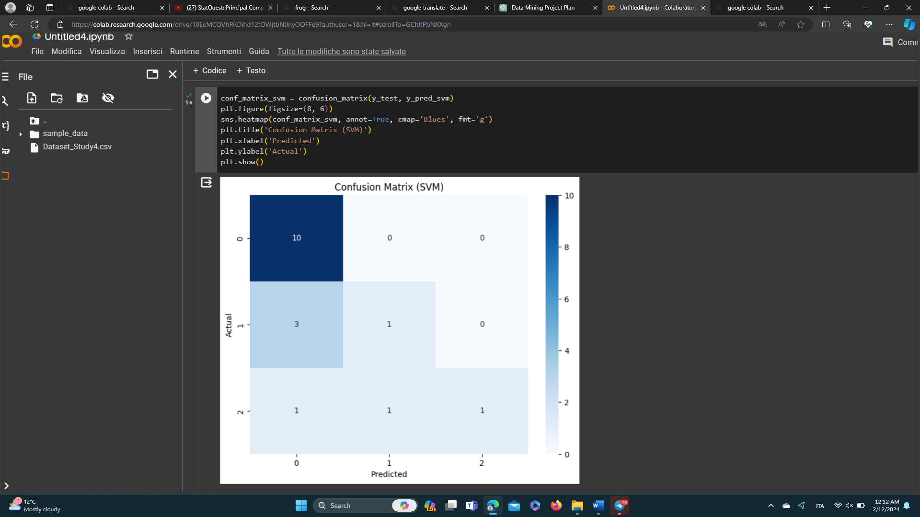

Conclusion

In summary, the Random Forest classifier achieved an accuracy of 56%, with relatively lower precision, recall, and F1-score values for the emotional states other than the baseline (-1).

The SVM classifier performed slightly better with an accuracy of 71%, showing higher precision, recall, and F1-score values across all classes. However, it still faces challenges in accurately predicting certain emotional states.

Overall, while both models show promise, there's room for improvement. Fine-tuning parameters and exploring additional features could enhance their predictive power.

References

1. Scikit-learn Documentation:
   * Link: <https://scikit-learn.org/stable/documentation.html>
2. Seaborn Documentation:
   * Link: <https://seaborn.pydata.org/tutorial.html>
3. Matplotlib Documentation:
   * Link: <https://matplotlib.org/stable/contents.html>
4. Pandas Documentation:
   * Link: <https://pandas.pydata.org/docs/>